Konzoly


KZ-1

KZ-2

KZ-5
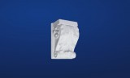
KZ-6

KZ-7

KZ-8

KZ-11
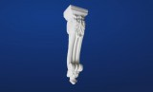
KZ-12
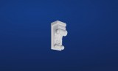
KZ-14

KZ-15
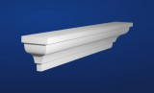
KZ-16

KZ-17

