Pilastre

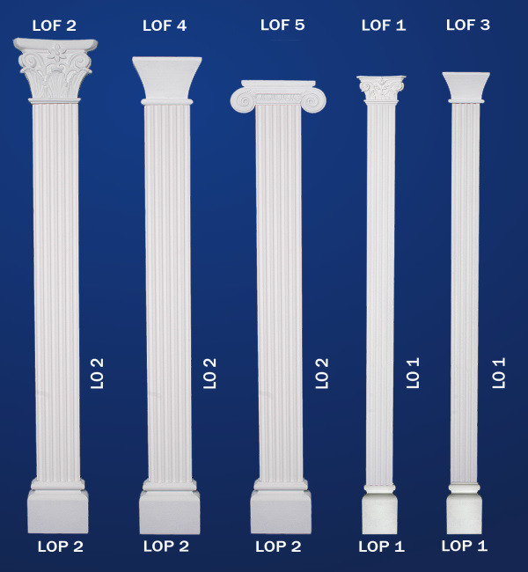

LOF-1

LOF-2

LOF-3

LOF-4

LOF-5

LO-1

LO-2

LOP-1

LOP-2

