Polostĺpy

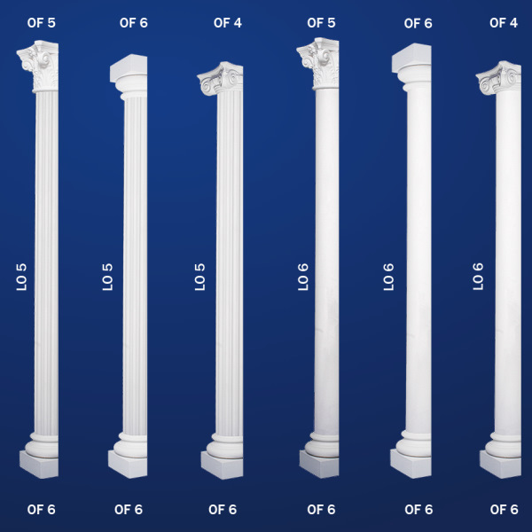

OF-4

OF-5

OF-6

LO-5

LO-6

